**ELEX 4440 Power Projects:**

**QEP Decoding and Motor Torque Measurements**

**Final Report**

Prepared for:

Kathy Manson

Jeff Bloemink

Susan Woo

Bahareh Shahabi

Instructors

British Columbia Institute of Technology

By:

Christopher Tesar

David Tran

Derek Yamamoto

Alvin Yang

Students

Electrical Power and Industrial Control Option

February 8, 2019

**Table of Contents**

Contents

**List of Tables & Figures** **2**

Summary **3**

**Introduction** **4**

**Project Description** **5**

Scope and Specifications 5

Procedure and Steps 6

MSP432 Microcontroller Programming and Simulations 6

Installing Project Components 6

Detailed Design 7

Microcontroller 7

Optical Speed Sensor 8

Direction 10

Load Cell 11

Load Cell Amplifier 11

Torque Calculation 11

Liquid Crystal Display 12

AC/DC Power Supply 13

Results 14

Technical challenges and solutions 15

Nonlinearity of the Load Cell Amplifier 17

**Schedule** **18**

**Bill of Materials** **19**

**Conclusion** **20**

**Recommendations** **21**

Appendix (refer to the downloaded powerpoint week 13 for formatting) **22**

References **29**

# List of Tables & Figures

*Figure 1: QEP Signal Path* 4

*Figure 2: Single disk, three sensor QEP decoder* 5

*Figure 3: Project Schedule* 6

Table 1: Budget 6

# Summary

The purpose of this final report is to outline the methodology used to implement the project of QEP Signals and Torque Measurements in room SW1-3075. By installing this project onto the motors in the power lab, students will be able to take speed measurements without the need to get close to the rotor of the motor making it safer. Torque measurements will be taken without the use of the current milk-scale and weights method using digital methods which will result in faster, more accurate results.

Speed and direction were measured using 2 optical sensors, an encoder disk and a reflective surface. By pointing the optical sensor through the encoder wheel onto the reflective surface behind it, QEP signals were generated which then get decoded in the microcontroller. An algorithm was created to calculate the time between pulses generated by the optical sensors. The time is then converted and displayed as motor speed onto an LCD. Direction was detected by taking the edge of sensor 1 and comparing it to the phase shift edge of sensor 2. Depending on the physical direction of the motor, the state of sensor 2 will either be high or low which is ultimately decoded into direction.

Torque was implemented using a load cell and a load cell amplifier. A voltage output is generated by changing the force applied to the load cell, This voltage is too small for the MSP432 display microcontroller to read so it is then boosted to a larger voltage using a load cell amplifier. This increased voltage is fed into the ADC of the microcontroller which then converts and stores it into a digital value. The final torque value is then displayed onto the LCD display.

The project started on February 1st, 2019 and was completed on April 1st, 2019. The final product was able to measure motor speed with accuracy comparable to the handheld tachometer. The torque measurements were also completed, however, the torque is only measurable in one direction. The load cell will output negative voltages if a downward torque is created which the microcontroller cannot read. The torque values displayed are accurate at low torque values. At higher torque values, the nonlinear characteristics of the load cell amplifier were prevalent which decreased the accuracy of the torque values.

The budget and deadline of the project was met. The estimated cost of installation on station was $1158.98 CAD. The actual total cost for implementation is $27.55 CAD under budget. The project was slightly delayed in the middle of March due to long sensor shipment times. This caused the implementations stage of the project to be pushed back to a later date. In the end, the project was installed on time.

It is recommended to replace the current 25 lb-ft load cell with a load cell rated for 50 lb-ft. This is because the starting dynamic torque of the motor can exceed 3 times the full load torque. The starting torque can reach an estimated 22 lb-ft which is very close to the current rating of the load cell. Another recommendation is to allow for the current torque set up to take negative torque measurement. This can be implemented by either having a microcontroller or PLC that can take negative voltage at the ADC. Another method is to have a circuit that changes the negative voltage to a positive voltage and take the direction of the motor into account to obtain both positive and negative torque.

# 

# Introduction

This report is prepared for Kathy Manson, Jeff Bloemink, Susan Woo, Bahareh Shahabi, and the Department of Electrical and Computer Engineering Technology (ECET) at British Columbia Institute of Technology (BCIT). Its purpose is to present the improvements made to the existing methods used to measure the torque and speed of the motors in the Power Lab (SW1-3075).

In order to measure the speed of the motor, students need to use a handheld tachometer that will project a laser onto the spinning rotor shaft. The light will then be returned back to the tachometer by a strip of reflective material that has been taped onto the shaft. The tachometer needs to be held ≤ 30 cm away from the motor for 3 seconds in order to get a steady measurement. This is hazardous as an article of clothing may get caught or the student could lose balance and fall onto the rotor. Another disadvantage is that the handheld devices rely on a 9 volt battery for power. Students regularly forget to switch the device off which will leave the battery drained for the next user. This is a problem as students will waste limited lab time to find a replacement battery. To solve this, a pair of optical speed sensors will be installed to the side of the motors eliminating the need to change batteries. This also eliminates the need to get close to the motor, reducing the risk of injury.

Current torque measurements use a milk-scale and a 10 lb weight connected to a foot long rod protruding from the motor. Measurements are inaccurate as the students have to visually interpret the analog needle on the milk-scale. Another problem is that the scales are not zeroed accurately making the zero of the scale ambiguous. To solve these problems, a load cell will be implemented that will digitize the measurements, eliminating the need for the milk-scale and 10 lb weights.

This report will detail the procedure of how the load cell and speed sensors were implemented, the results that were collected, the solutions to the many problems that occurred, and the recommendations on how the project can be improved.

# Project Description

## Scope and Specifications

In order for this project to be successful, users will have to be able to take both speed and torque measurements by digital means. Users will be able to take data by reading the measurements from the LCD screen. This will allow for measurements to be taken quickly and safely. For speed measurements the following criteria will be met to ensure quality of measurements:

1. Continuous and accurate speed measurements for up to 2000 RPM
2. Measurements taken far from rotor of the motor for safety
3. Value update rate faster than 2 seconds
4. Use of microcontroller so additional features can be implemented

The limitations of the speed portion of the project comes down to the speed sensors, microcontroller speed and cost of the project. The speed sensors have a rating of 1 kHz which can be exceeded if the number of encoder wheel slots, with respect to the max motor speed of 2000 RPM, are not taken into account. This can be prevented by covering some of the open spaces of the encoder wheel. By leaving 15 slots open on the encoder wheel, a theoretical motor speed of 4000 RPM can be measured.

Another limitation is the processing speed of the microcontroller. The method used to detect direction makes use of the interrupt function of the microcontroller. If the program written in the microcontroller is too slow, the time to execute the code interferes with the next triggered interrupt. This has been taken into account when writing the speed calculation program.

For torque measurements, the project aims to prioritize accuracy and ease of measurement taking. Taking this into account, the following criteria will be met:

1. Removing the 10 lb weights to increase safety
2. Replacing the milk-scale using a digital interface and measurement method
3. Measure both positive and negative torque using rigid mounting system
4. Able to display one decimal point of accuracy

The limitations of the torque portion of the project is the accuracy to calibrate the load cell. By observing the output of the load cell amplifier, it was found that the amplifier displayed a non-linear output. This must be accounted for as it greatly decreases the output accuracy at higher torque values.

The following examples would be considered out of the scope parameters:

1. Mechanical power output of the motor
2. Taking other measurements such as dynamic torque at motor start up

## 

## Procedure and Steps

### MSP432 Microcontroller Programming and Simulations

While waiting for the optical sensors and power supply to arrive, preliminary microcontroller code was written to simulate functions of the final product. To simulate speed, 2 function generators were utilized to simulate the QEP signals the optical speed sensors would register from the encoder track . Doing this, the program for speed and direction was written and tested without the need for the actual sensors. This step was essential to the success of the project as the sensors arrived late. By performing simulations before hand, the sensors were implemented with ease.

Torque simulations were also performed as the load cell and load cell amplifier were ready for use. This was performed by wiring up the load cell and load cell amplifier to the bench top power supply and observing the characteristics of the load cell. By pulling on the load cell, a motor applying torque was simulated and the signal was sent into the microcontroller. By having the program ready by doing simulations, real test runs could be done faster and more efficiently.

### Installing Project Components

After programming the microcontroller, sensors and load cell were physically implemented. The optical sensors were installed by drilling 2 holes in the acrylic sheet which will hold the sensors in front of the motor. This was done using a drill press. The size of the drill bit was determined after tracing the location and size of the holes onto the acrylic. After the holes were made, the sensors were fit into place and the bracing that held the acrylic was reassembled.

The load cell was installed onto the base of the the motor bench seen in *figures 1 & 2,* using a U-Bracket and self tapping screws. First, the bottom of the load cell was screwed onto the U-Bracket using a ¼” - 28 screw. The U-Bracket was the screwed onto the base of the motor using self tapping screws. The top of the load cell was then screwed onto the rigid rod connecting to the motor torque rod.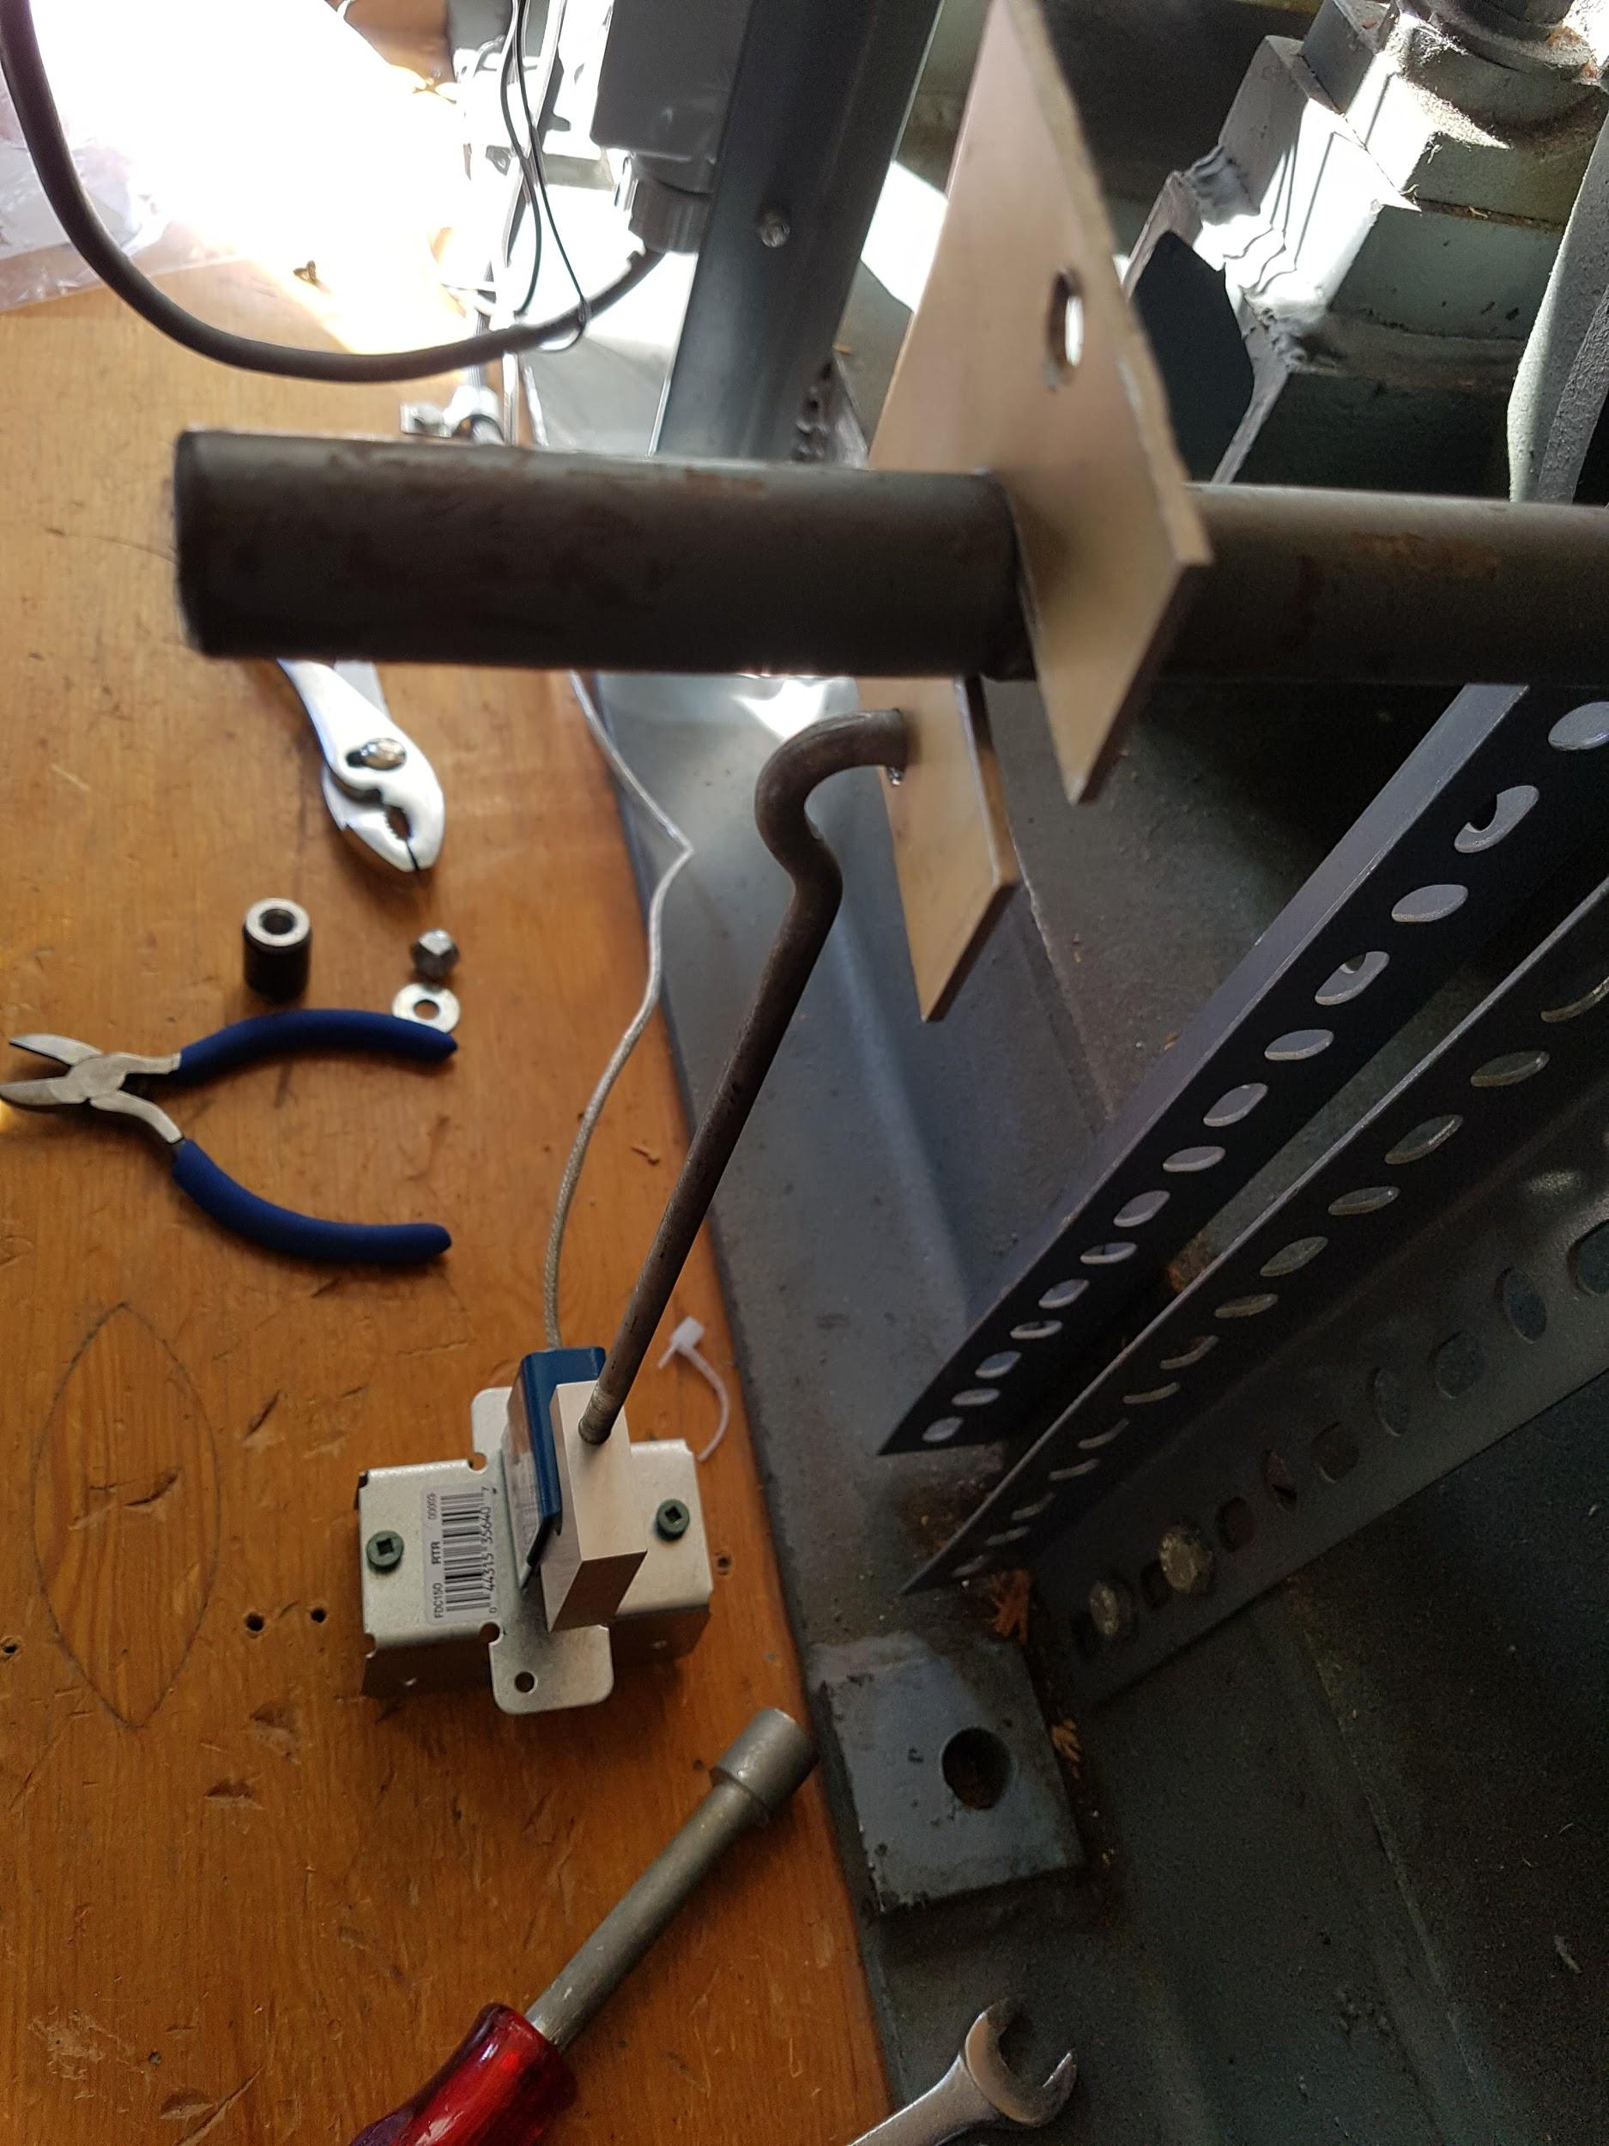 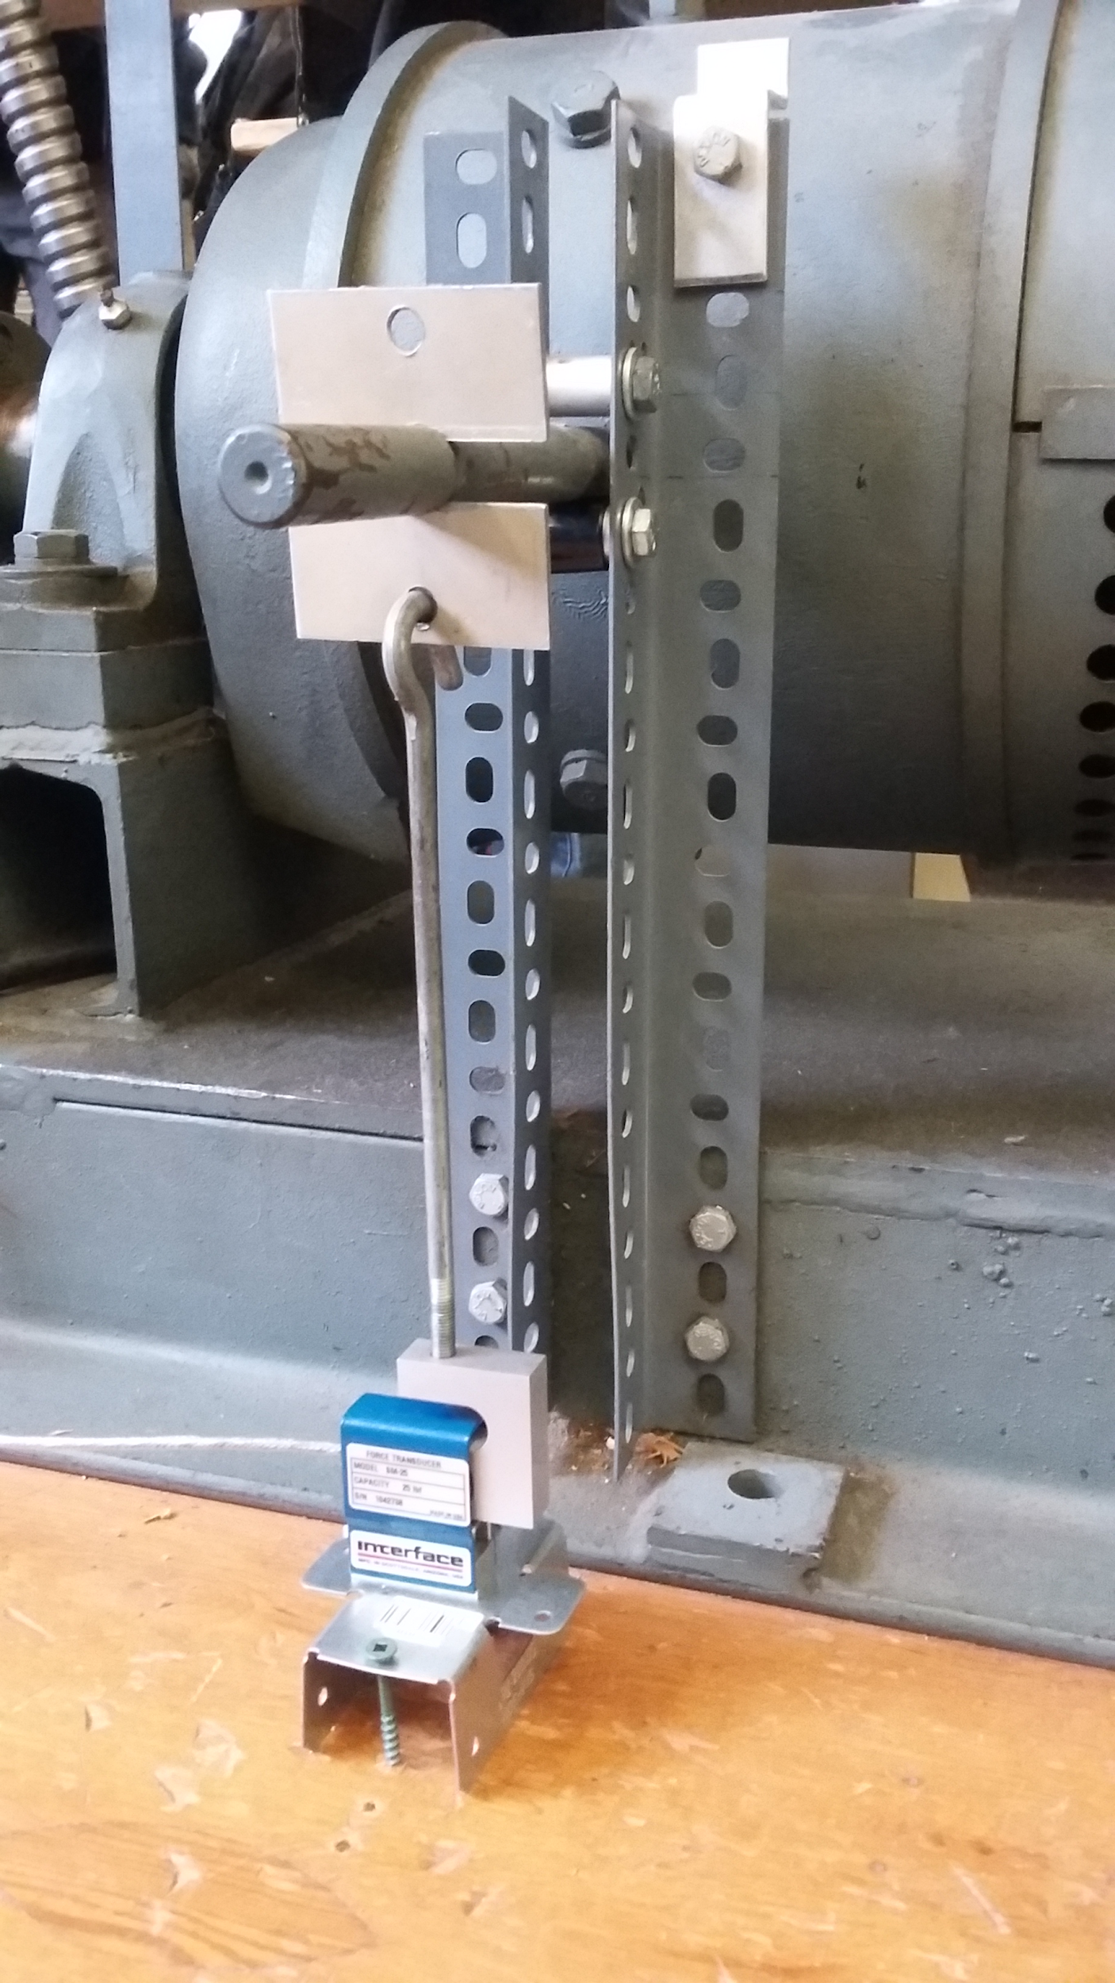

*Figure 1: Birds eye view of torque measurement set up Figure 2: Profile shot of torque measurement set up*

## 

## Detailed Design

This project utilizes a microcontroller to interpret data received from various sensors to calculate the speed, torque, and direction of a motor. The block diagram of the system is shown in *figure 3*.

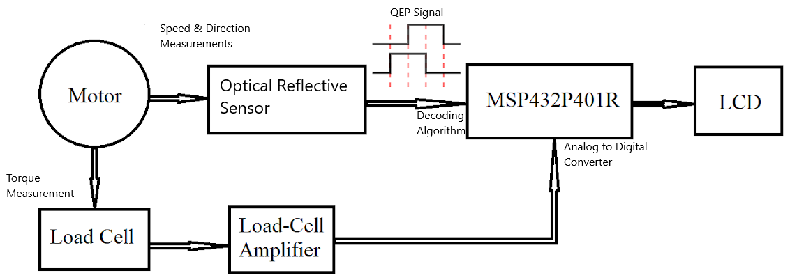

*Figure 3: System block diagram*

A load cell is connected to the motor to measure torque. The output voltage of the load cell is fed into a amplifier to boost the signal to a readable level for the microcontroller before entering. Separate from the load cell, the reflective optical sensors measure the speed of rotation of the motor shaft. The optical sensors create QEP pulses which are sent to the microcontroller. The microcontroller then calculates torque, speed, and direction before sending it to be displayed on the LCD.

### Microcontroller

A MSP432P401R microcontroller has been chosen for this project because it required the use of an analog to digital converter (ADC) and a timer to measure the torque and speed of the motor, respectively. The selected microcontroller provides the required ADC and timer needed, as well as providing the ability of using interrupts. The ADC is required to measure the torque as the load cell output is an analog voltage signal. The timer is used to calculate the speed of the motor by measuring the frequency of the rotating pulses. The ability to utilize interrupts increases the accuracy of the speed and direction measurements by reducing the risk of missing a pulse during the regular polling operation of the microcontroller.

### 

### Optical Speed Sensor

Reflective optical sensors have been selected as the optimal choice to measure the speed and produce the QEP signals used to determine the direction of the motors. The Shimpo MCS-655P optical sensor shown in *figure 4*, was chosen as it met the criteria for the motor and microcontroller to measure speed and direction.These optical sensors use an NPN open collector output and are rated for 1 kHz. The interior circuit of the output can been seen in *figure 5*.

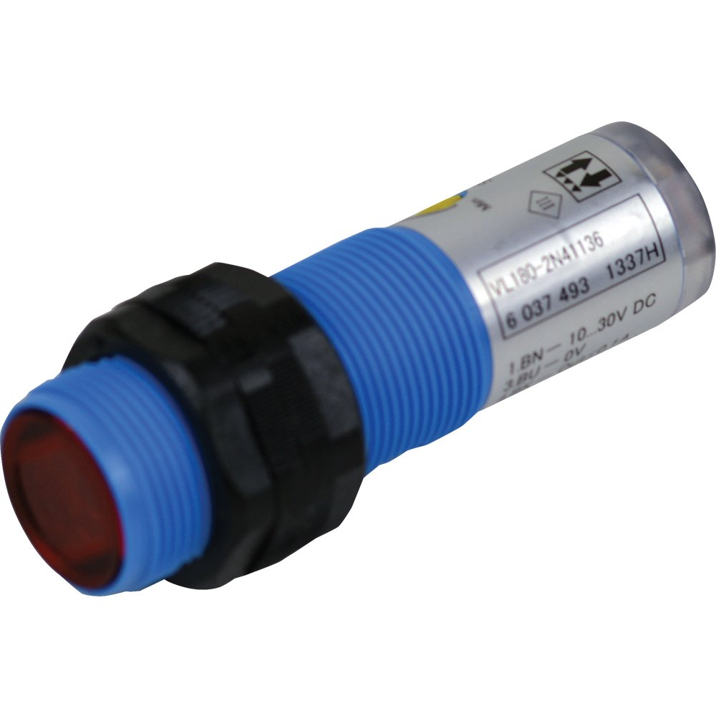

*Figure 4: Shimpo MCS-655P - Reflective Optical Sensor*

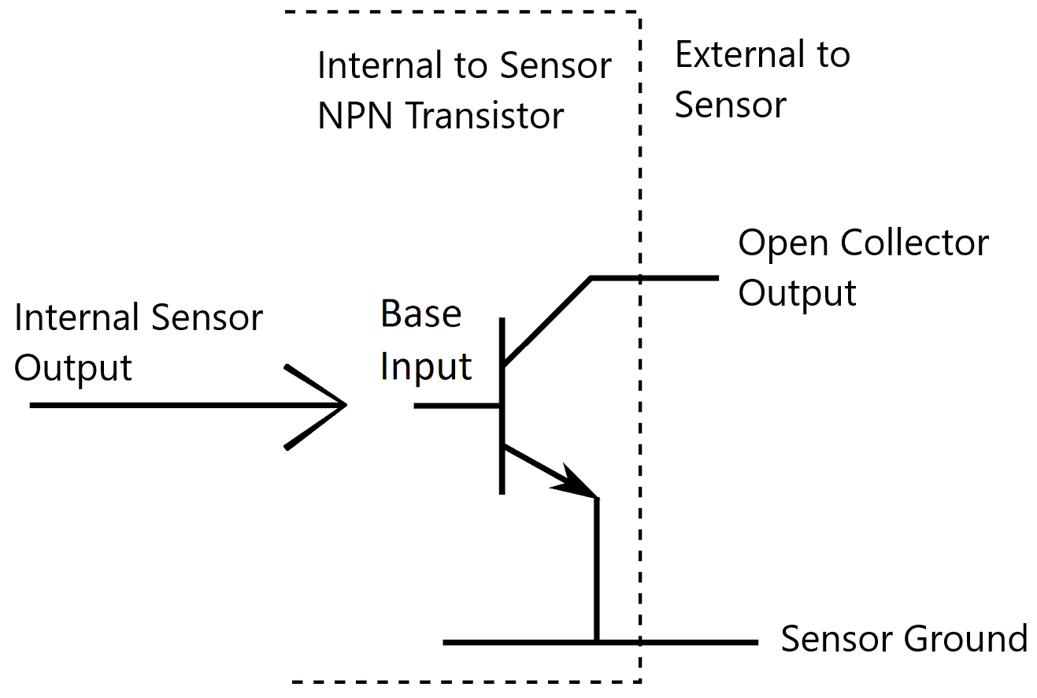

*Figure 5: NPN open collector optical sensor output*

When the optical sensor is activated it applies voltage to the base input of the transistor. To create the desired square wave pulses to measure speed and direction, a pull up resistor has been connected to the open collector output of the optical sensor.

**Speed Calculation**

A reflective optical sensor rated up to 60,000 RPM is used with the optical encoder disk to measure the speed of the motor. The optical encoder disk originally contained 45 evenly spaced gaps. The optical sensor is installed over these gaps with a reflective plate installed behind the disk. The optical sensor creates a pulse each time a gap rotates past it. For calculations, the max speed of the motors has been taken as 2000 RPM. With this max speed, if all 45 gaps on the optical encoder disk are used a pulsing speed of 90,000 RPM would be created. The sensors aren’t rated for this speed so the number of gaps was reduced to the next lowest value of 15 while still maintaining an even spacing, shown in *figure 6*. With 15 gaps the effective speed seen by the sensors is only 30,000 RPM at the max speed.

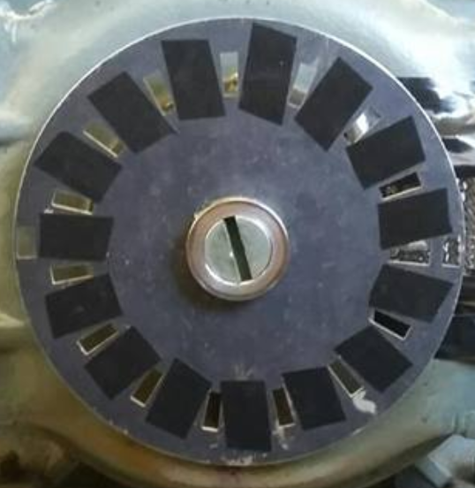

*Figure 6: Optical encoder disk with 15 evenly spaced gaps*

The microcontroller measures the speed of the motor by measuring the frequency of the pulses. To accomplish this a timer is set to continuously count up to a specified value. Once a pulse from the sensor is detected, the timers current value is stored as the initial time value. A second time value is stored once the sensor receives a second pulse.

To account for any rollovers of the timer, a variable was created. It is set to 0 when the initial time value is captured and then counts upward for each timer roll over. The final roll over count value is then multiplied with the timers period. This total roll over period will then get added to the final time. To summarize, the microcontroller will measure the change in time difference between pulses using the following formula:

T_difference = (T_Period * Time_Count + Time_2) - Time_1

T_difference is the difference between the first edge capture and the second edge capture. T_Period the timer period with the value of 32768. This period value was set to achieve the desired 1 second period using a 32.768 kHz clock. It is noted that the 1 second timer period isn’t restricted by any parameters and was chosen for simplicity and convenience. Time_Count will then record the number of times the timer completes a count and rolls over until the second pulse, Time_2, is detected. Time_Count is reset when the initial time, Time_1 value is taken.

### Direction

The direction of the motor was determined using QEP signals. These QEP signals require 2 sensors with an ideal phase shift of 90° between the outputs. The ideal output waveforms of QEP signals can be seen in *figure 7*.

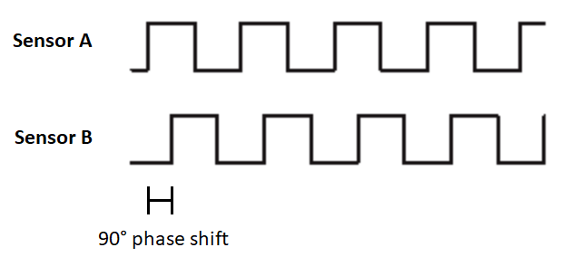

*Figure 7: Ideal QEP output waveforms*

An interrupt triggered on the falling edge of sensor A is utilized to determine the direction of the motor. The state that both signals are detected in are affected by the direction the motor is running in. If the motor were to be operated with a positive sequence then the falling edge of sensor A will occur when sensor B is high going represented by going left to right in *figure 7*. However, if the motor is operated with a negative sequence supply then, by going right to left in *figure 7*, the falling edge of sensor A will occur when sensor B is low . With this relationship defined, the interrupt will check the state of sensor B and set a flag indicating whether it’s a high or a low value. The state of this flag represents the direction of rotation which will be displayed on the LCD as positive sequence or negative sequence.

### 

### Load Cell

The load cell is the key component that will measure the torque of the motor. The model used is the SM S-Type Load Cell, shown in *figure 8***.**

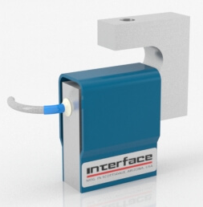

*Figure 8: Interface SM S-Type Load Cell*

Acting as a transducer, the load cell will take the force applied and convert it to a small output voltage. The range of the output voltage will depend on the excitation voltage and the rated torque. The ratio specified in the datasheet is that at the rated torque of 25 lb-ft, the load cell will output 3.27889mV for every 1V applied to the excitation. For example, if an excitation voltage of 1V is applied to the load cell and a 25 lb-ft force is induced, the output of the load cell will be ~3.3mV. This small voltage will then be applied the the load cell amplifier to to output a voltage between 0 - 3.3V.

### Load Cell Amplifier

The load cell amplifier is supplied with 24V. The amplifier then supplies the load cell with 12V of excitation. Due to the relationship between the output and excitation of the load cell, it now has an output range of 0 - 39.3 mV. This poses an issue as the value is still too small for the ADC input on the microcontroller to effectively read it. To solve this a load cell amplifier was implemented to scale the low output voltage produced by the load cell so that the microcontroller could accurately read it.

### Torque Calculation

The original plan was to install the load cell onto the the wire between the milk-scale and torque bar. This plan didn’t involve removing the milk-scale and weight but would effectively cut the range of the load cell in half due the 10 lb-ft offset from the weights. This offset could lead to damage from the inrush torque so it was decided to install the load cell below the torque bar. Installing the load cell below the bar would provide us with the ability to measure positive and negative torque using the full 25 lb-ft rating in both directions.

The final torque value is based on the output of the load cell amplifier and the microcontroller ADC. The output of the load cell amplifier is a value that ranges between 0 - 3.3V, depending on the amount of torque applied on the load cell. The microcontroller ADC is configured to take the amplifier output value between 0 - 3.3V and convert it into an 8 bit integer between 0 - 255. The torque values are scaled in the microcontroller program afterwards which are then sent to the LCD to displayed the final torque values.

### 

### Liquid Crystal Display

The Liquid Crystal Display (LCD) is configured to display the measurements (speed, torque, direction) individually but the user can switch the measurement being shown by activating a push button. The LCD uses a 4 data line method to send 8 bit data to the LCD from the microcontroller. The LCD is connected to the microcontroller and power supply as shown in *figure 9*.

~~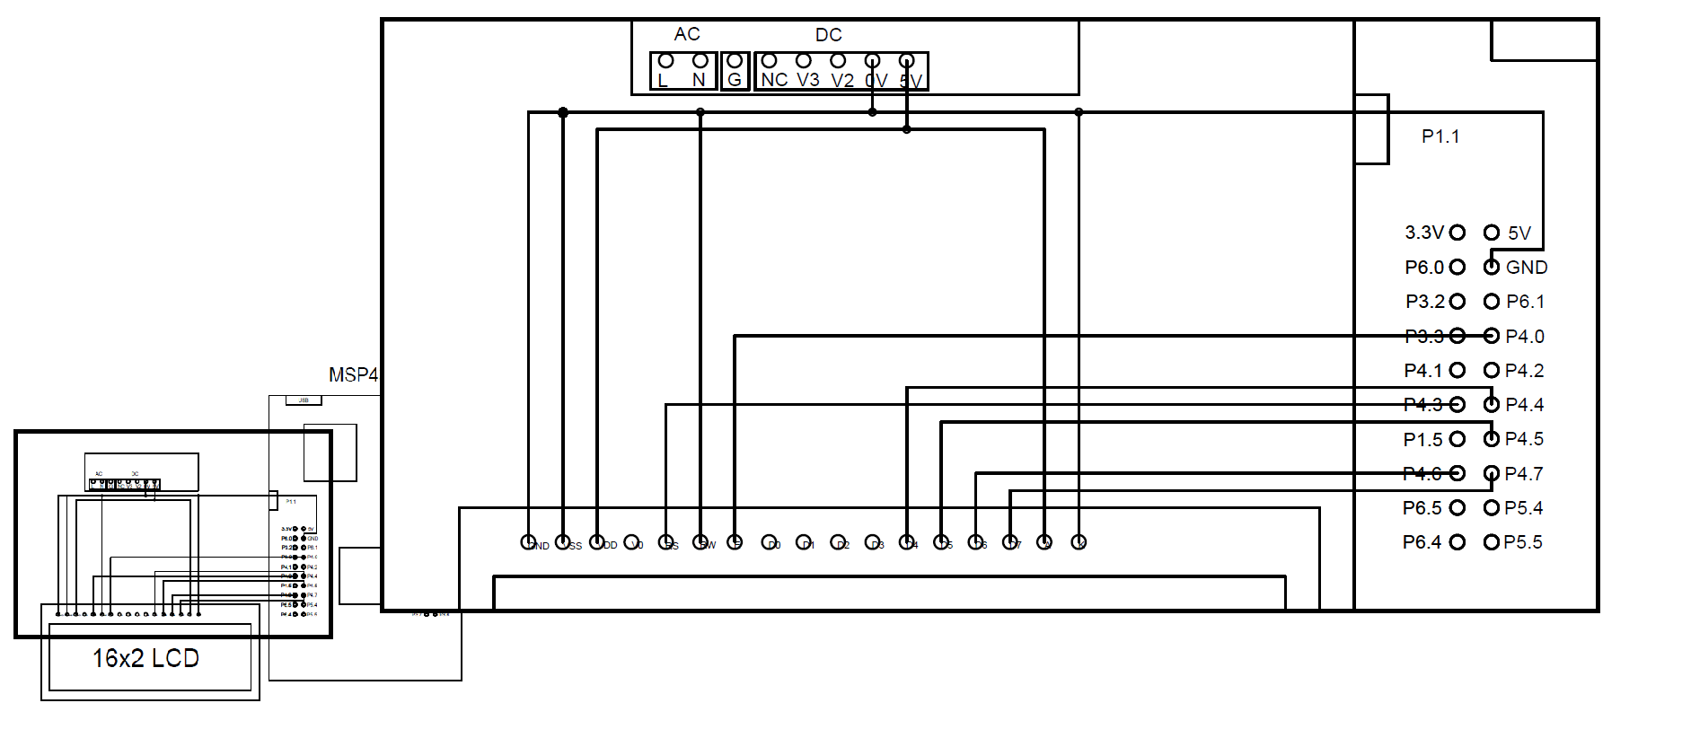~~

*Figure 9: Microcontroller - LCD connections*

The A and Vdd pins are connected to a 5V DC external power supply output in order to power the LCD drive module. Pins K and VSS are connected to COM of the power supply. Ground of the microcontroller is connected to COM of the power supply. V0 is connected to a potentiometer, which is also connected across the 5V power supply. The contrast of the screen can be adjusted through V0 by the potentiometer. Pins RS, E, and D4 - D7 are wired to the microcontroller input/output pins. RW is tied to ground to enable the write function as the read function is unused. RS is connected from P4.3, E is connected from P4.0 and D4 - D7 is connected to P4.4 - P4.7 respectively.

### 

### 

### AC/DC Power Supply

The power supply seen in *figure 10* is used to provide the voltages required for the speed and torque measurements. This is a AC-DC switch mode power supply with a 5 volt, 12 volt (V3), and a 24 volt (+V2) output.

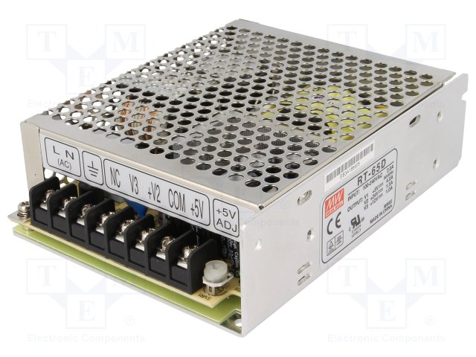

*Figure 10: Mean Well - 50W triple output switching power supply*

The pull up resistors connected to the optical sensor output, as well as the LCD are supplied by the 5 volt output. The load cell amplifier and the optical sensors use the 24 and 12 volt outputs respectively. The microcontroller is currently powered through a usb wall adapter, this however can be changed to use the 5 volt output of the power supply.

## 

## Results

To confirm the functionality and accuracy of the displayed speed, various samples were recorded at different speeds and compared to a tachometer. The graph shown in *figure 11* compares the displayed speed on the LCD with the tachometer speed.

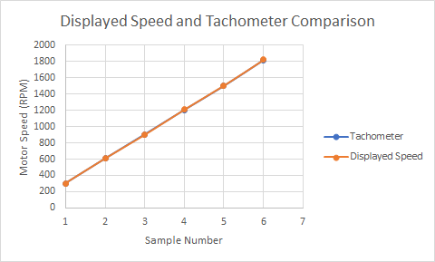

*Figure 11: Measured tachometer & displayed speed*

By observing the graph above, one can see that the displayed speed is fairly close to the measured tachometer speed. It was noticed that at higher speeds, the error between the tachometer and displayed speed increased. This may be due to microcontroller processing speeds or the algorithm used to implement the speed calculation.

Torque values were also able to be taken in one direction. Looking at *figure 12* below, a sample torque value is displayed on the LCD.

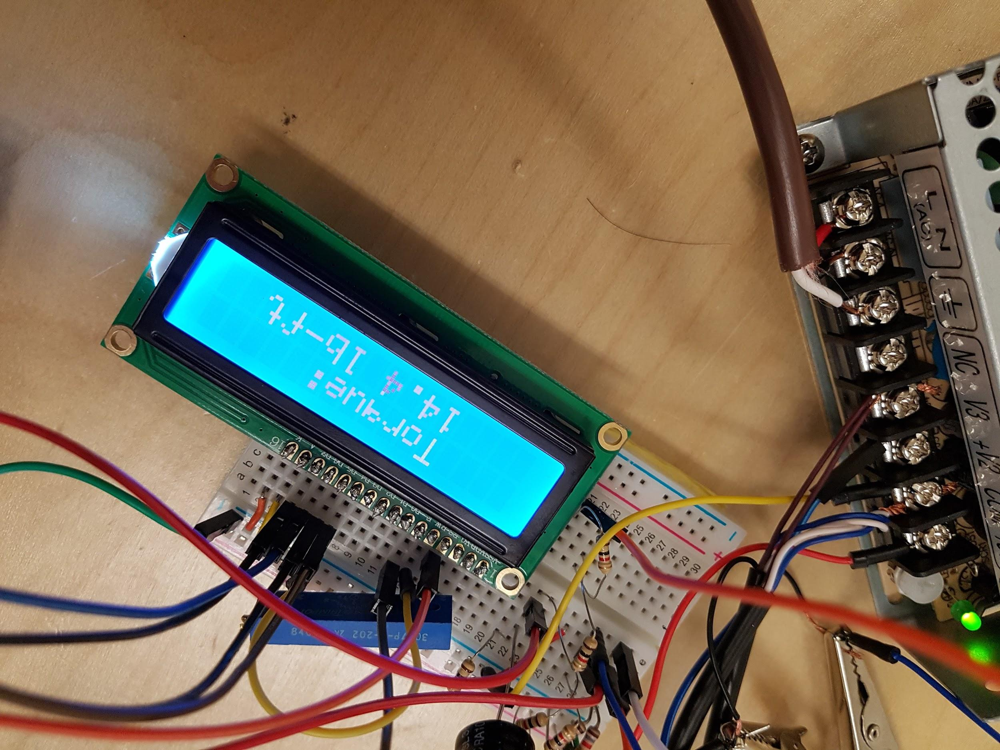

*Figure 12: Simulated torque values*

At lower torque values, the load cell amplifier displays proper torque values. However, as the torque increases, the values on the display do not increase at the same rate as the actual torque. This can be fixed by taking the nonlinearity of the load cell amplifier into account through scaling it in the microcontroller.

Displaying direction onto the LCD was a success as it was able to be measured at both low frequencies as well as high frequencies. When spinning the wheel by hand and switching directions continuously, the direction of the motor was recorded and displayed nearly instantaneously and without error. The display was also accurate at the rated speed of 1800 RPM. In *figure 13*, the LCD is displaying the phase sequence of the motor. This corresponds to a clockwise rotation of the motor when looking from the encoder disk side.

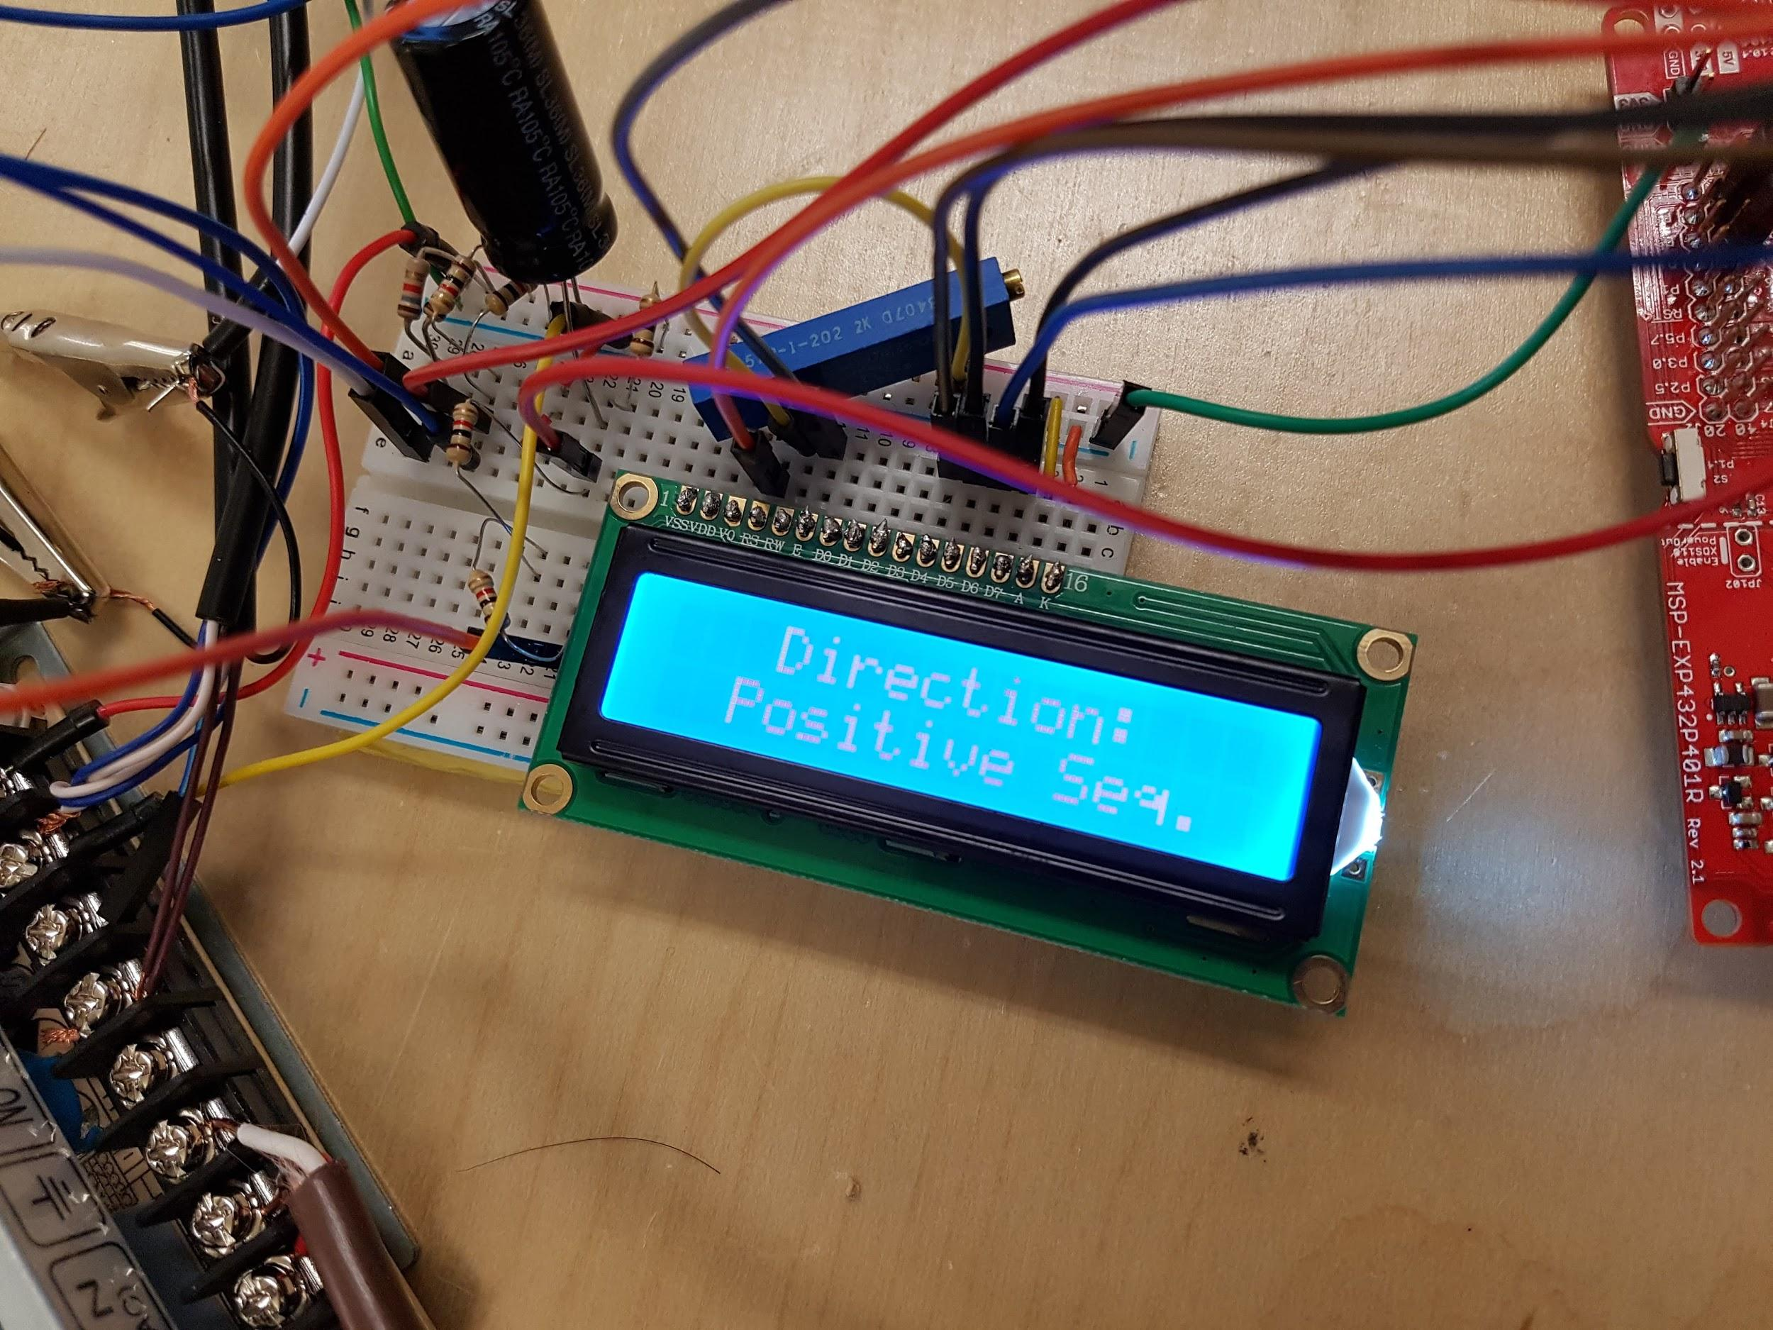

*Figure 13: Displayed direction sequence*

The text could easily be changed to say clockwise or counter clockwise instead of positive and negative sequence. This may be desirable because when the DC motor is used as a prime mover, it is inaccurate to call it positive and negative sequence because DC motors do not use phase sequence to determine direction.

## Technical challenges and solutions

**High Current Draw From LCD**

While the speed sensors were being delivered, a function generator was used to simulate the square wave pulses that would be generated from the sensors.

A simple program was written to trigger an interrupt that would blink a small LED on and off when the microcontroller detected the falling edge of a square wave. At this stage a problem occurred while trying to input the simulated signals of the function generator into the program. Projecting the waveforms onto an oscilloscope screen, the theoretical output waveform of the microcontroller should have closely mimicked the input square wave. During testing however, the output waveform bounced and switched states randomly. The microcontroller was also incredibly hot during this testing period. The cause was attributed to the high current draw of approximately 19mA of the LCD.

To solve this, an external power supply was brought in to power the LCD separately instead of using the on-board 5V power supply of the microcontroller. This solution resolved both the high temperatures the microcontroller was producing but also the bouncing observed on the output waveform. The conclusion was that the LCD was drawing too much power and interfered with the microcontroller input/output functions.

**Speed Software Debugging**

The speed simulations had more problems on the software side as well. The first method of calculating speed that was tested involved having a timer that continually counted to an X number of seconds. While the timer was running, a waveform edge detector counted the pulses . At the end of the timer count, the pulses would be tallied up and the timer would reset to 0. This result gave the pulses per second. This value was then converted to rotations per minute.

This method proved to work but with the disadvantage of providing slightly inaccurate results. Due to the way the code was programmed, having a timer setting of 1 second gave a discrepancy of +-30 RPM. This meant the LCD updated every second with an accuracy of +-30 RPM. If the timer settings were to be changed to 4 seconds, the accuracy would be improved to +-7.5 RPM but with the downside of having the LCD only update the value shown every 4 seconds. It was determined that the update period and accuracy using this method is not acceptable.

To resolve this, a new algorithm was implemented to calculate the speed of the motor. The new method worked under the principle of using the built in timer to measure the frequency between pulses, as discussed in Detailed Design under Speed.

**Direction Simulation**

A small problem occurred when using two function generators, one operated with an analog dial and the other with a digital display, to produce two seperate square waves. In order to simulate the two optical sensors needed to generate direction, the two waveforms were required to have the same frequency. It was difficult to match the frequencies while still having a phase shift in between.

This problem was managed by triggering the oscilloscope on the digital function generator and adjusting the analog function generator to minimize the frequency difference. The two waveforms frequencies were never completely matched and stable. The frequency difference was adjusted low enough so that the triggered waveform would lead the other for a few seconds before the edges of both waveforms passed each other and the triggered waveform would now be lagging. Since direction was determined by sensor B being either high or low when sensor A was triggered, the frequency difference ended up working for us as it effectively simulated the motor changing directions whenever the edges passed each other.

**Motor Vibrations**

After installing the load cell and load cell amplifier to the motor, when torque was applied to the load cell, the displayed torque value on the LCD would fluctuate ± 0.5 lb-ft. When the load cell amplifier output was probed with an oscilloscope, a consistent voltage ripple was generated as shown in *figure 14*.

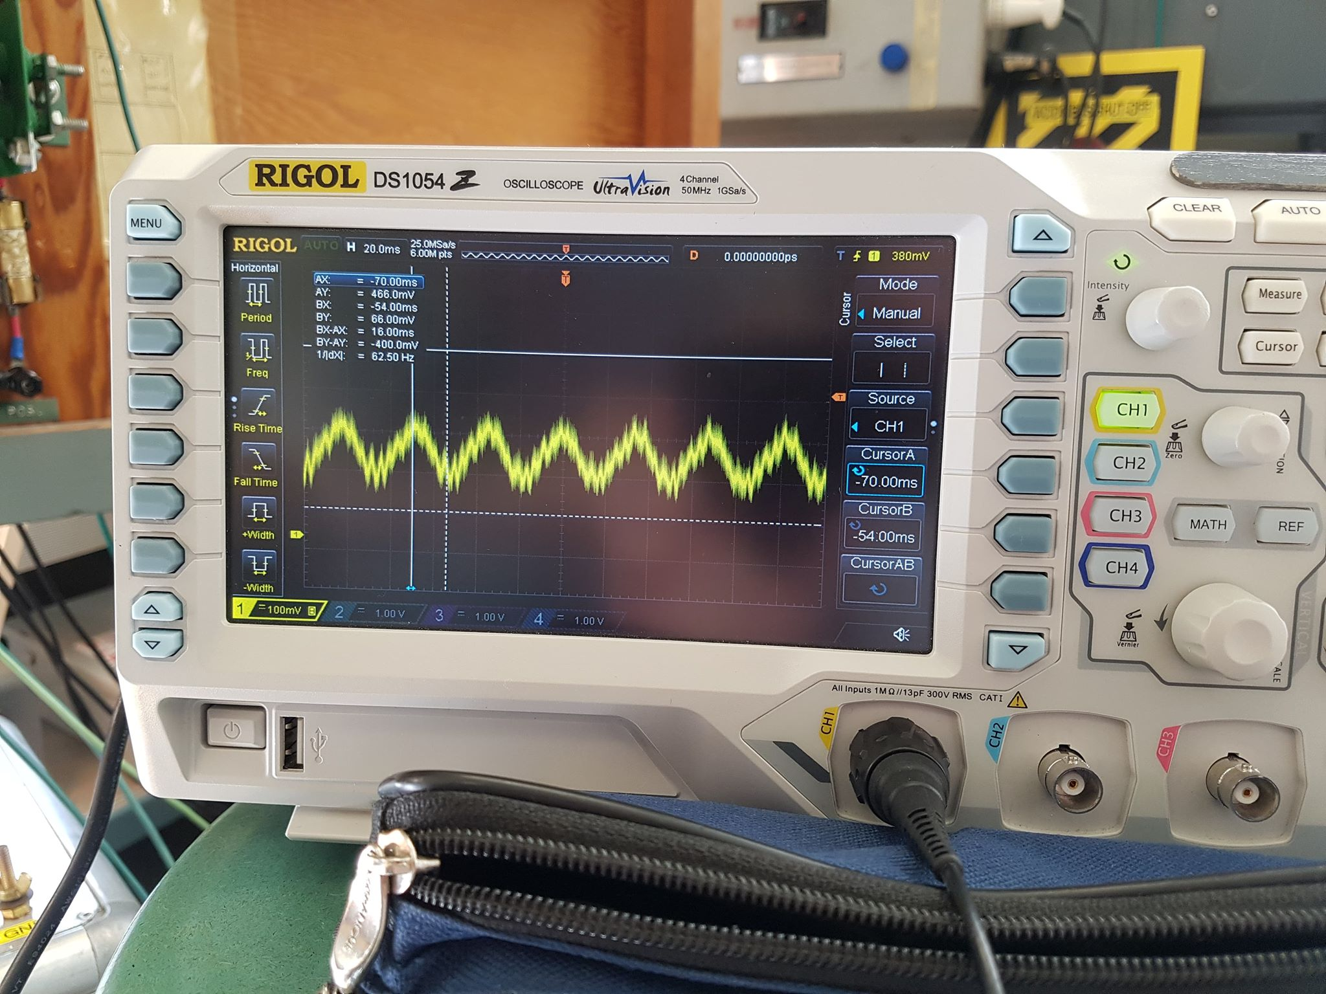

*Figure 14: Measured 30 Hz voltage ripple of torque amplifier output.*

It was deduced that the voltage ripple was caused by the non-ideal characteristics of the motor. This was determined by measuring the frequency of the voltage ripple while the motor was running at 1800 RPM. The measured frequency of the amplifier waveform was 30 Hz. Using the conversion method of 1 RPM = 1/60 Hz, the frequency of the motor running at 1800 RPM was 30 Hz. Since the frequency of the voltage ripple was equivalent to the mechanical frequency of the motor, it was concluded that the voltage ripple was caused by the motor. The displayed torque was stabilized by implementing a low pass filter with a 1000µF to the output. This filtered out the AC component of the waveform leaving only the desired DC component which resulted in the output torque becoming stable.

### Nonlinearity of the Load Cell Amplifier

The load cell amplifier produced a non-linear reading while testing the torque of the motor. The amplifier was tested by comparing the output voltage of the amplifier with the output voltage of the load cell as the load cell is very accurate and proportional with the torque applied. As the torque of the motor increased, the output of the amplifier slowly did not increase linearly with respect to the load cell output.

This problem can be solved by programming the microcontroller to offset the non-linear characteristic of the load cell amplifier. By taking many data points at specific torque values, the data can be tabulated and graphed. The nonlinear curve can be estimated using a exponential function that matches the curve of the load cell amplifier. This exponential function can be written into the microcontroller to offset the nonlinear properties.

# Schedule

In *table 1* below, the predicted finish dates given in the proposal and actual finish dates can be seen.

*Table 1: Final schedule*

|  |  |  |  |
| --- | --- | --- | --- |
| Tasks | Predicted Finish Date | Start Date | Finish Date |
| Research Microcontroller | 3-Feb | 1-Feb | 3-Feb |
| Research Load-cell | 11-Feb | 6-Feb | 11-Feb |
| Torque Simulations | 15-Feb | 8-Feb | 17-Feb |
| Research Sensors | 17-Feb | 16-Mar | 18-Mar |
| Sensor Simulations | 22-Feb | 18-Feb | 4-Mar |
| Torque Implementation | 22-Feb | 21-Mar | 27-Mar |
| Sensor Implementation | 1-Mar | 21-Mar | 22-Mar |
| Display Speed and Direction | 15-Mar | 25-Mar | 28-Mar |
| Final Presentation | 5-Apr | 5-Apr | 5-Apr |
| Formal Report | 8-Apr | 8-Apr | 8-Apr |

The predicted completion date was similar to the actual completed date for the first couple of weeks. However, the implementation stage of the project was delayed due to the delayed shipment of the sensors as well as refining the code to match project specifications.

# 

# Bill of Materials

*Table 2* shows the quantity and price of the important components bought to complete the project. It does not include minor costs such as wires used on the breadboard.

*Table 2: Bill of Materials*

|  |  |  |  |
| --- | --- | --- | --- |
| **Item** | **Quantity** | **Unit**  **Price** | **Total**  **Price** |
| SM S-Type Load Cell (25 lb-ft) - Interface Force | 1 | $416.00 | $416.00 |
| A1A-22 Load Cell Amplifier - Anyload Weight and Measure Inc. | 1 | $190.00 | $190.00 |
| Metal U-Bracket - Home Depot | 1 | $2.99 | $2.99 |
| MSP432P401R SimpleLink Mixed-Signal Microcontroller | 2 | $30.53 | $61.06 |
| HD44780 LCD - Hitachi | 2 | $9.95 | $19.90 |
| MCS-655P Photo-Reflective Speed Sensor - Shimpo Instruments | 2 | $190.64 | $381.28 |
| RT-65D AC/DC Converter 5V 24V 12V - Mean Well USA Inc. | 1 | $48.00 | $48.00 |
| Double Pole 3-Wire Plug Black - Home Depot | 1 | $7.48 | $7.48 |
| Low Voltage 18 Gauge 3-Wire Brown - Home Depot | 1 | $4.72 | $4.72 |
| **Total Expenses** | |  | **$1,131.43** |

The final cost to create the prototype was $1,131.43. However, the cost to recreate the project will only be $1,090.95 as the final cost includes buying a replacement for the microcontroller and LCD. The total expense is within the original proposed budget of $1,158.98 by $27.55.

# 

# Conclusion

The scope of the project was to replace the handheld tachometer and the milk-scale for speed and torque measurements by implementing a digital method to take measurements. By implementing the project, students are able to take quick and accurate torque and speed measurements while staying far from the rotor. Overall, the project scope has been met as accurate speed, direction and torque measurements are able to be taken. The current project is implemented so that new features and additions can be easily added onto the project.

The project provided many valuable learning experiences. The importance of time management and communication was made very apparent as the project progressed. Teamwork was stressed as various tasks needed to be distributed amongst team members. This project provides a viable method to take measurements in the power lab.

# 

# 

# Recommendations

1. Change the connection between the rigid rod and motor torque rod

The current connection between the rigid rod and motor rod is not completely secure when the load cell receives a downward torque. This prevents the load cell from producing negative values and will cause the connector to fall off the motor rod and damage the load cell. A more sturdy connection is required between the rigid rod and the motor rod.

1. Use a pushbutton to “hold” currently displayed Values

Implementing this function would be very useful because the values displayed on the LCD will change values rapidly at higher motor speeds. Since the refresh rate of the measurements and the LCD is very fast, it is difficult to read the displayed values. Implementing a button that would hold values will allow speed to be easily read even if the values are rapidly changing.

1. Increase load cell rating (50 lb-ft)

Changing the load cell rating is recommended because the motor starting torque can be 3 times the full load torque. The estimated starting torque is to be around 22 lb-ft which is very close to the rating of the load cell. A 50 lb-ft load cell would have no worry of exceeding its rated torque.

1. Find the curve of the load cell amplifier and scale torque values accordingly

To get very accurate torque values, the load cell amplifier will need to be scaled in the microcontroller. This is because of the nonlinear property of the load cell amplifier. Through measuring the output of the load cell amplifier and getting a corresponding curve, one could estimate the amplifier curve with a mathematical exponential function. Using this function, the microcontroller can be scaled accordingly.

1. Use voltage magnitude and utilize the direction of the motor to assign positive and negative torque.

Since the output of the amplifier has the possibility of producing negative voltages, an inverting amplifier circuit can be created to produce only positive voltages. Taking into account the direction of the motor, if the motor is running so that a negative torque would be produced, the voltage signal would be directed through an inverter. A positive torque would go straight into the microcontroller

# Appendix (refer to the downloaded powerpoint week 13 for formatting)



**Interface SM S-Type Load Cell (25 lb-ft)**

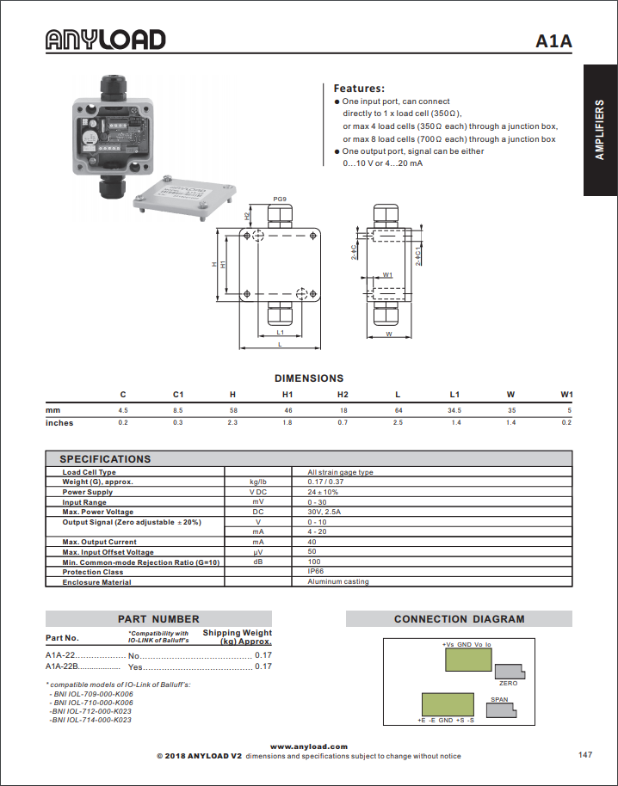

**A1A-22 Load Cell Amplifier**

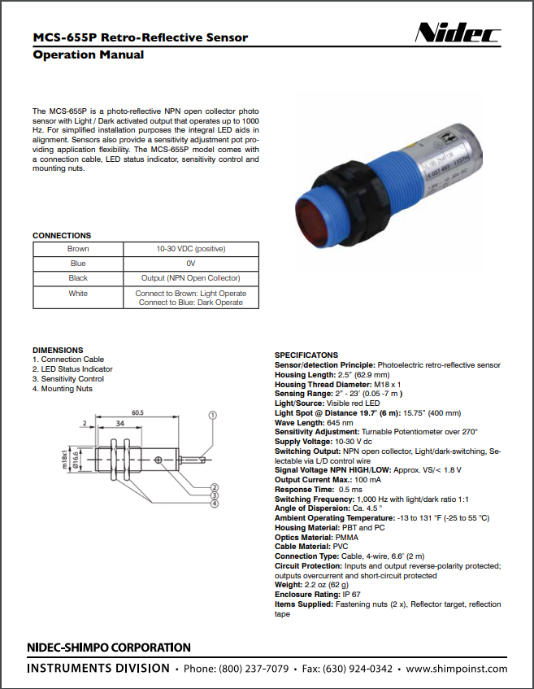

**SHIMPO MCS-655P Retro-Reflective Sensor**

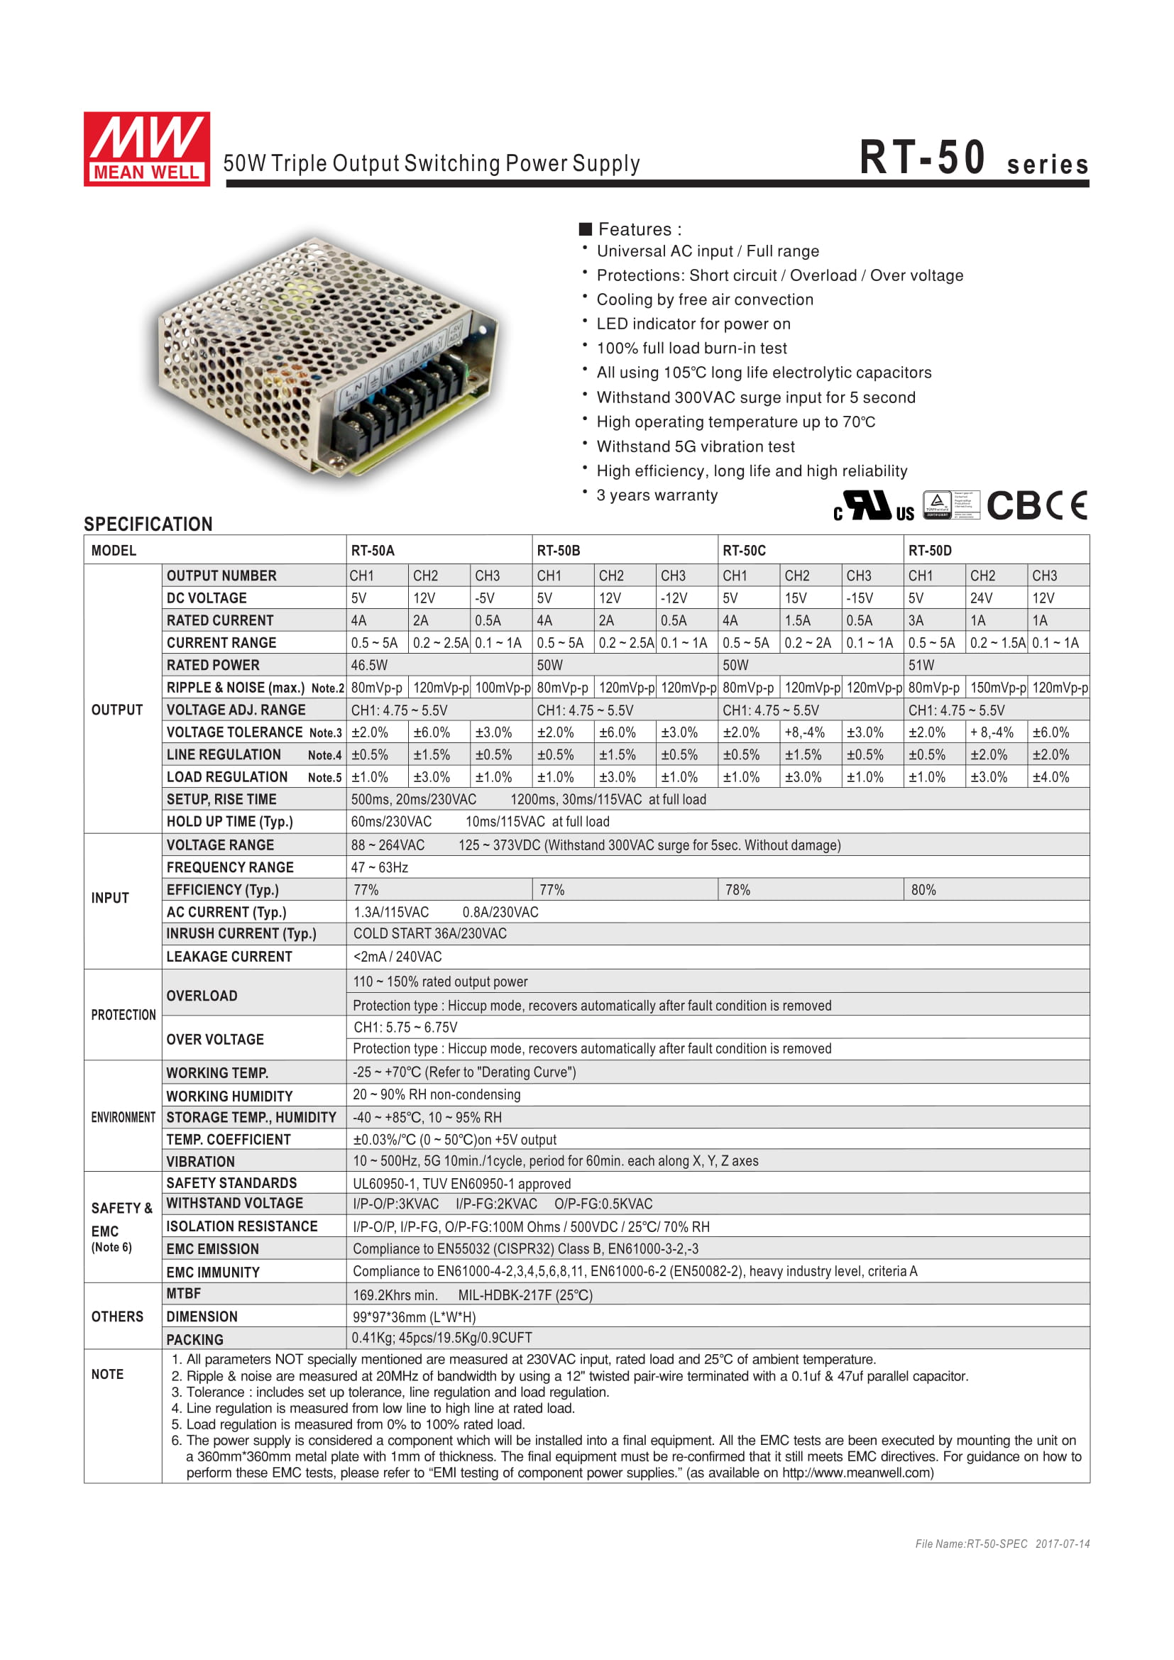

**Meanwell Triple Output 50W Switching Power Supply (Page 1)**

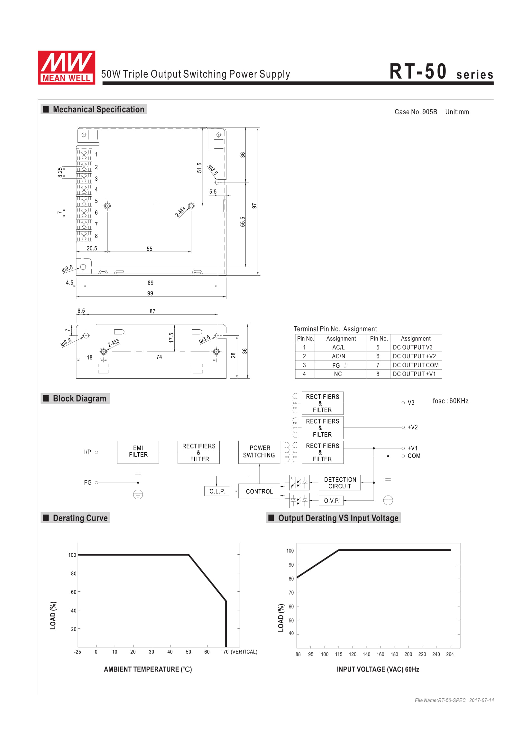

**Meanwell Triple Output 50W Switching Power Supply (Page 2)**

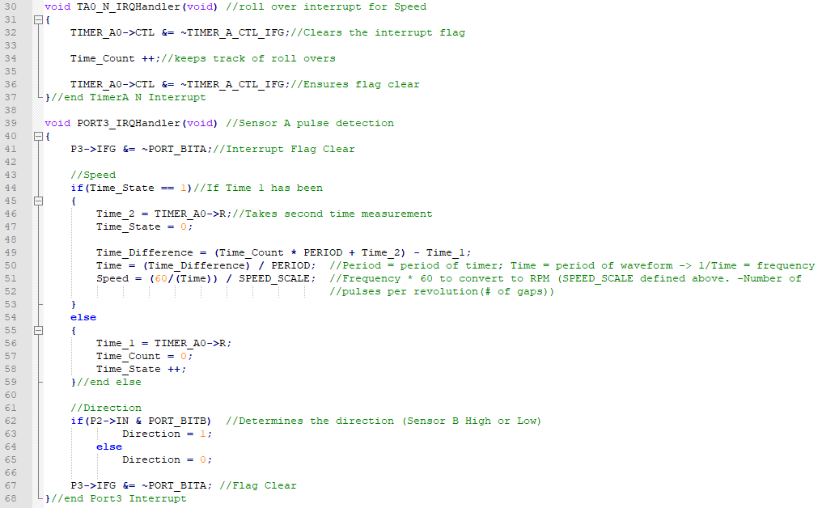

**Code used to determine Speed & Direction**

### 

**Optical sensor wiring schematic**

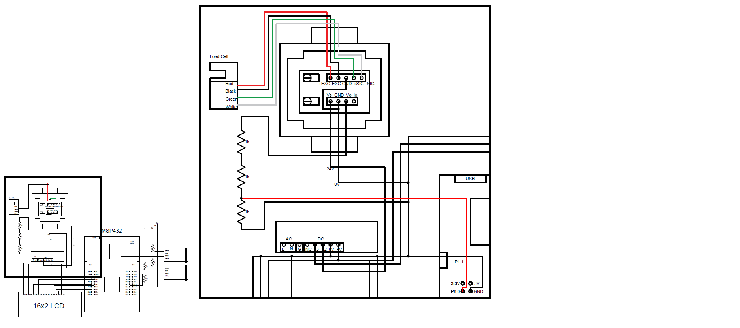

**Load cell & load cell amplifier wiring schematic**

# References

|  |  |
| --- | --- |
| [1] | R. Ivanov, A. Kerezov and I. Lesichkov, "Algorithms for Decoding Quadrature Encoded Pulses," [Online]. Available: http://ecad.tu-sofia.bg/et/1999/Statii%20ET99-I/Algorithms%20for%20Decoding%20Quadrature%20Encoded%20Pulses.pdf. [Accessed 16 January 2019]. |
| [2] | S. Latif, A. Wong and G. Lehal, "Speed & Torque Measurement Upgrade," BCIT, Burnaby, 2018. |
| [3] | Texas Instruments, "TMS320x2833x, 2823x Enhanced Quadrature Encoder Pulse (eQEP) Module Reference Guide," Texas Instruments Incorporated, Dallas, 2008. |